**SQL vs NoSQL Databases and Features of MongoDB**

# Introduction to Databases

Databases are essential components of software systems for storing, retrieving, and managing data. Over the years, two major types of database systems have evolved: SQL (Structured Query Language) databases and NoSQL (Not Only SQL) databases. Understanding the differences between them is crucial for choosing the right technology based on the application requirements.

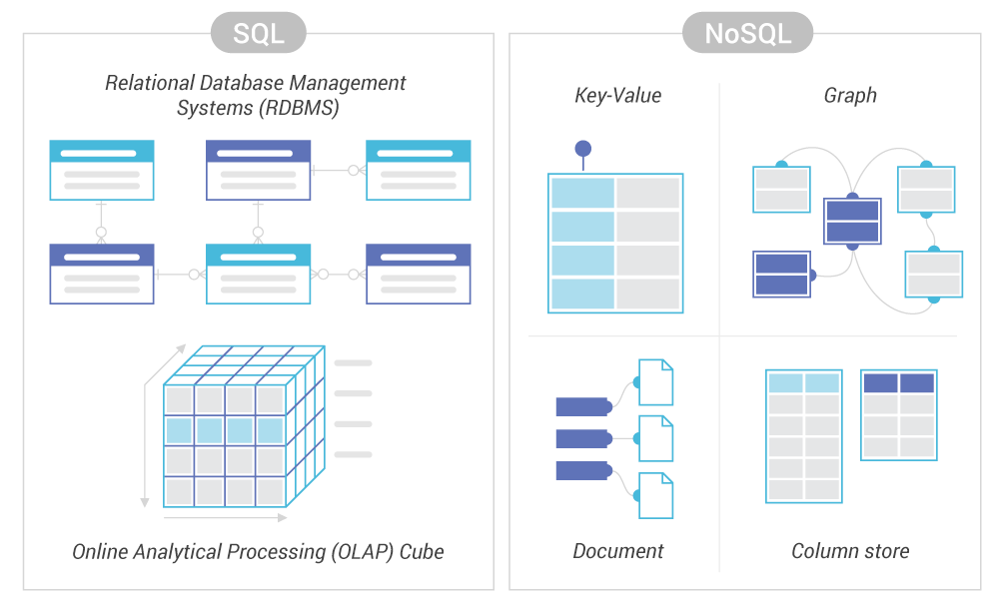

# SQL Databases

SQL databases, also known as relational databases, store data in structured tables with rows and columns. Each table represents an entity, and relationships between tables are maintained using foreign keys.

# Key Features of SQL Databases:

- Structured Schema: Data is stored in predefined schemas with clearly defined data types and constraints.

- ACID Compliance: SQL databases follow Atomicity, Consistency, Isolation, and Durability principles to ensure data integrity.

- Relational Model: Relationships between tables can be established using joins and foreign keys.

- Powerful Query Language: SQL provides a standardized language for querying and manipulating data.

- Transaction Support: Ideal for applications that require multi-step transactions (e.g., banking, e-commerce).

# Pros of SQL Databases:

- High data integrity and accuracy.

- Strong consistency guarantees.

- Mature technology with a large support community.

# Cons of SQL Databases:

- Less flexible with evolving data structures.

- Scaling can be difficult—vertical scaling is usually required.

# NoSQL Databases

NoSQL databases provide a more flexible way of storing and accessing data. They are designed to handle large volumes of unstructured, semi-structured, or rapidly changing data.

# Key Features of NoSQL Databases:

- Schema-less Design: Allows storage of varied and dynamic data structures without the need for predefined schema.

- Horizontal Scalability: Easily scales across multiple servers, making it ideal for big data and real-time applications.

- Varied Data Models: Supports different types of data models like key-value pairs, document-oriented, wide-column stores, and graph databases.

- High Performance: Optimized for fast reads and writes with distributed architecture.

# Pros of NoSQL Databases:

- Flexibility in data storage and modeling.

- Better suited for large-scale and high-speed applications.

- Simple setup and fast development.

# Cons of NoSQL Databases:

- Lack of standardization across different NoSQL databases.

- Weaker consistency (eventual consistency in many systems).

- Complex querying compared to SQL.

# Features of MongoDB

MongoDB is one of the most popular NoSQL databases, known for its document-oriented storage model. It stores data in JSON-like BSON (Binary JSON) format, making it highly flexible and scalable.

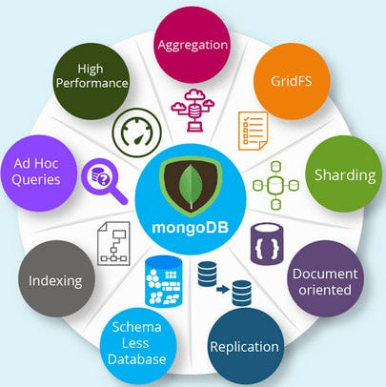

# Core Features of MongoDB:

- Document-Oriented Storage: Data is stored in the form of documents (similar to JSON objects).

- Schema Flexibility: Store documents with different structures in the same collection.

- Scalability and High Availability: Horizontal scaling via sharding and replication sets for high availability.

- Powerful Query Language: Rich query language supporting filters, projections, and aggregations.

- Indexing Support: Includes single field, compound, geospatial, and text indexes.

- Aggregation Framework: Allows computation and transformation of documents for analytics.

- Replication and Fault Tolerance: Ensures availability and redundancy.

- Integrated File Storage: GridFS enables handling large files.

- Open Source and Community Support: Strong developer ecosystem and tools.

- Rich Ecosystem and Tools: Includes MongoDB Compass, Atlas, and multi-language connectors.

# Conclusion

Both SQL and NoSQL databases have their strengths and are suitable for different scenarios. SQL databases are ideal when data integrity and relational data models are crucial. In contrast, NoSQL databases like MongoDB are better suited for projects with dynamic, large-scale, or unstructured data requirements. MongoDB, with its flexibility, scalability, and developer-friendly features, continues to be a leading choice for modern application development.